Project - 1: Deploying a Multi-Tier Website Using AWS EC2

Description:

Amazon Elastic Compute Cloud (Amazon EC2) provides scalable computing

capacity in the Amazon Web Services (AWS) cloud. Using Amazon EC2

eliminates your need to invest in hardware up front so you can develop and

deploy applications faster. You can use Amazon EC2 to launch as many or as

few virtual servers as you need, configure security and networking, and manage

storage. Amazon EC2 enables you to scale up or down to handle changes in

requirements or spikes in popularity, reducing your need to forecast traffic.

Problem Statement:

Company ABC wants to move their product to AWS. They have the following

things set up right now:

1. MySQL DB

2. Website (PHP)

The company wants high availability on this product, therefore wants Auto

Scaling to be enabled on this website.

Steps To Solve:

1. Launch an EC2 Instance

2. Enable Auto Scaling on these instances (minimum 2)

3. Create an RDS Instance

4. Create Database & Table in RDS instance:

a. Database name: intel

b. Table name: data

c. Database password: intel123

5. Change hostname in website

6. Allow traffic from EC2 to RDS instance

7. Allow all-traffic to EC2 instance

Solution:

1.EC2 instance Created

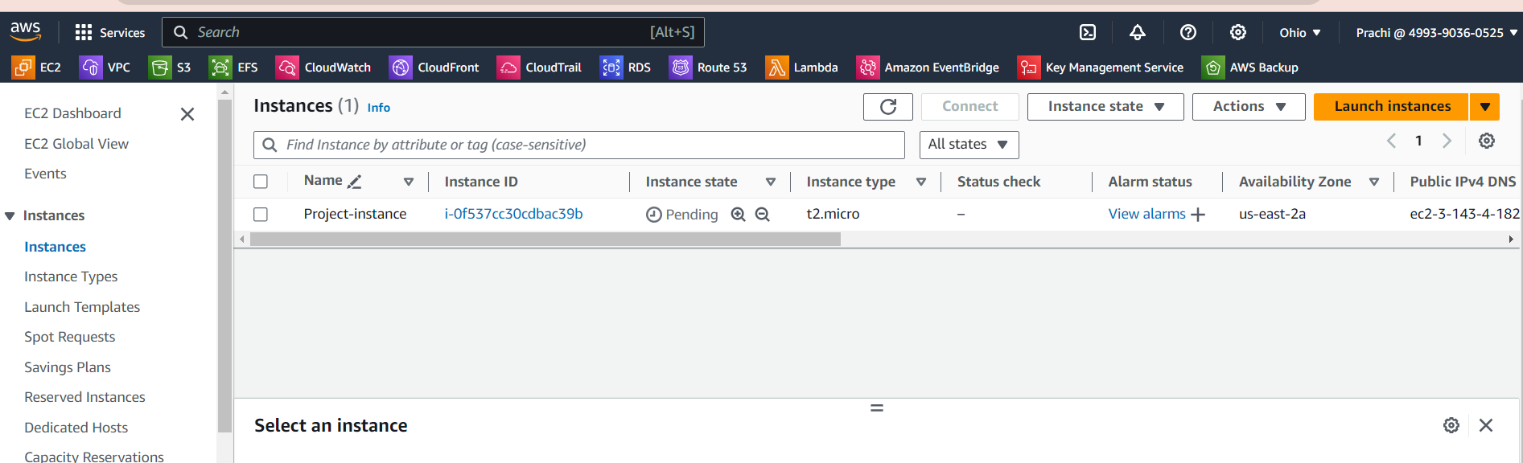

Webserver installed

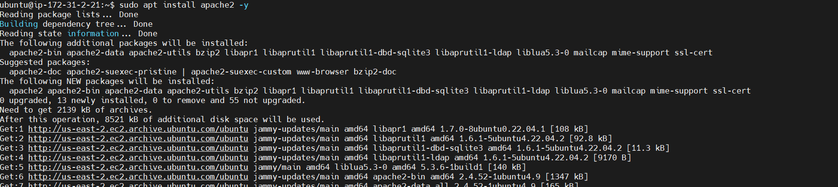

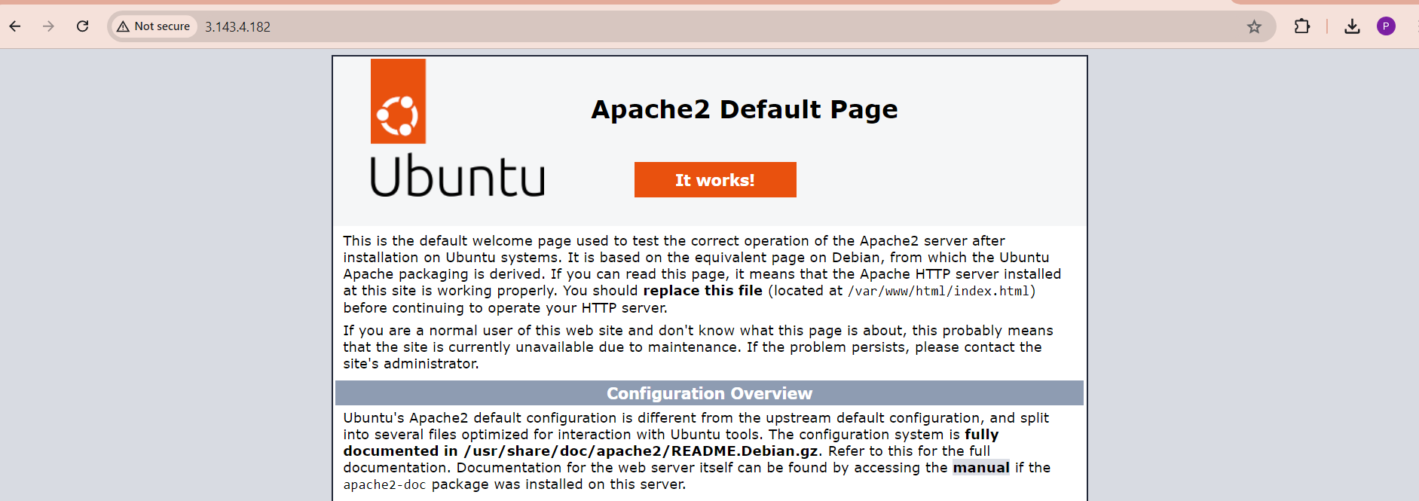

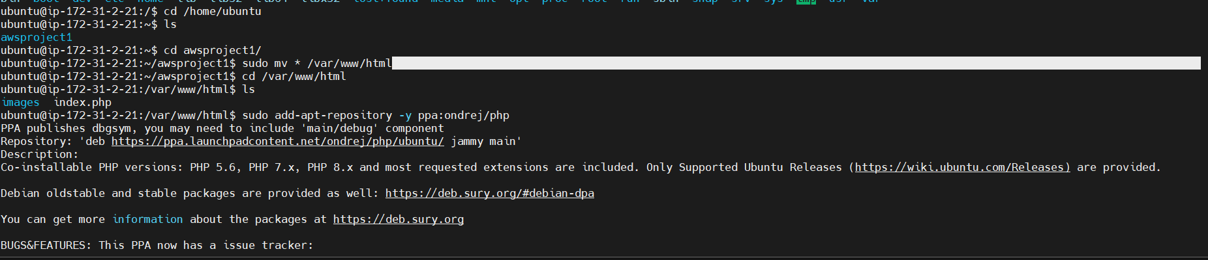

Public ip fetch for PHP website but connect error

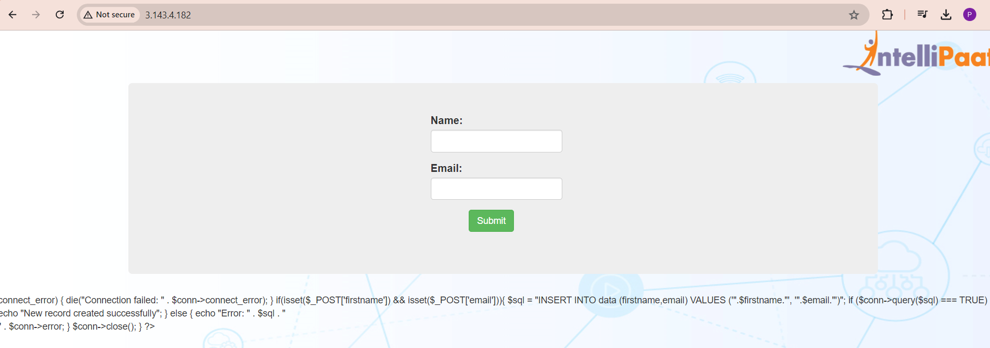

Creating database

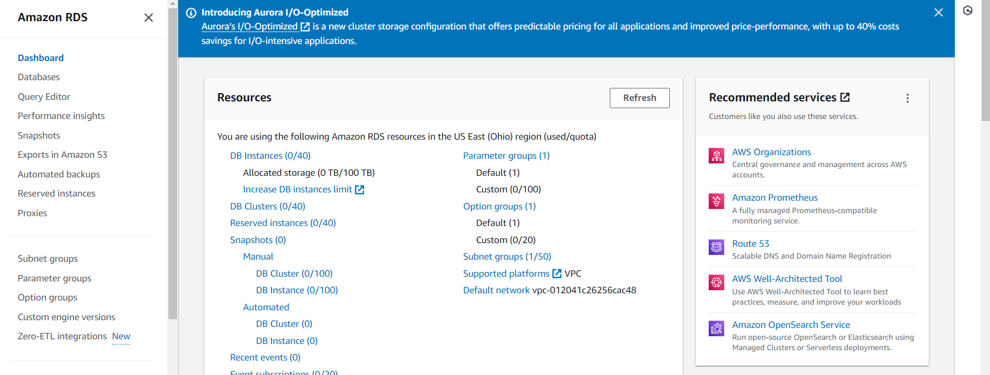

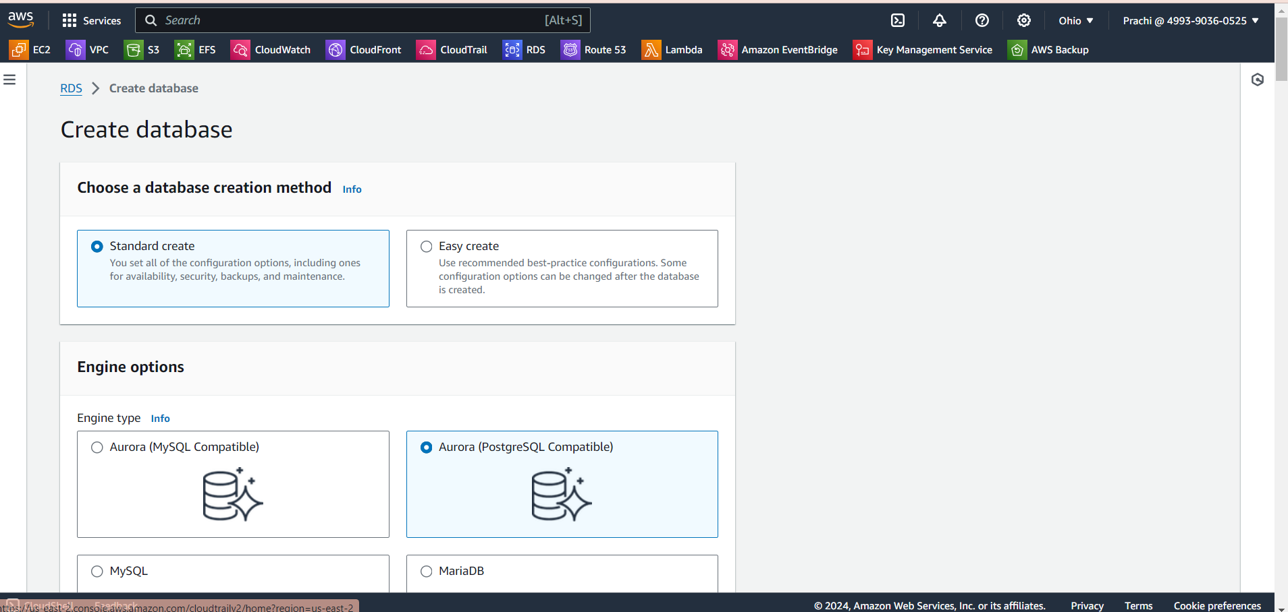

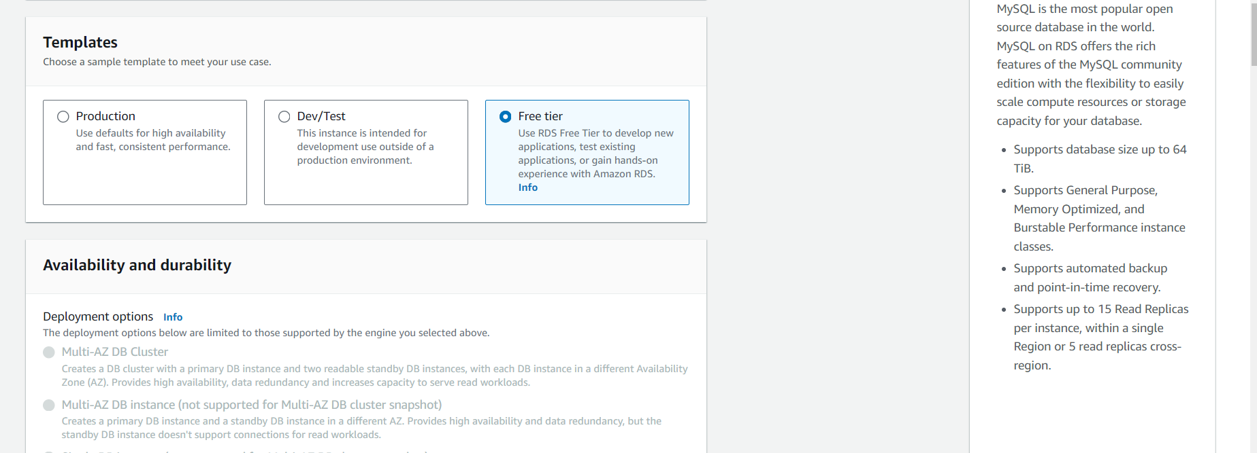

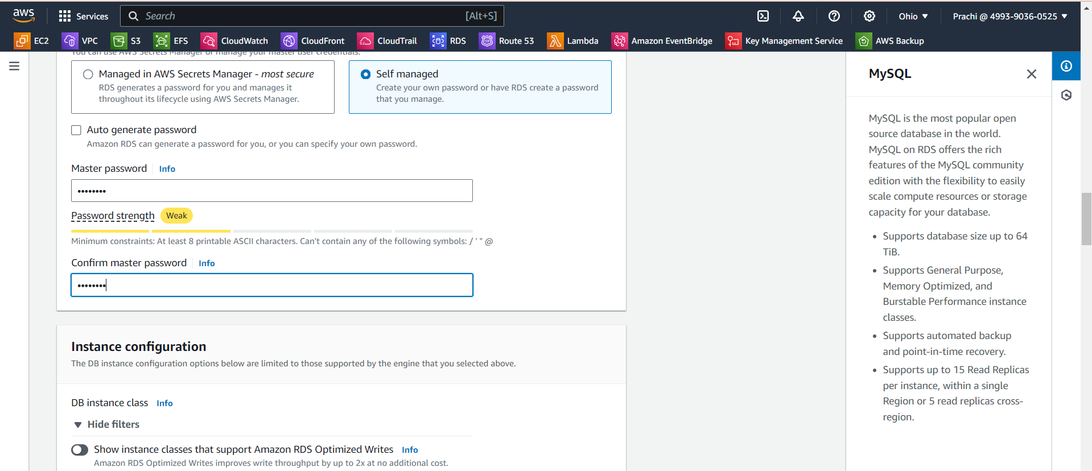

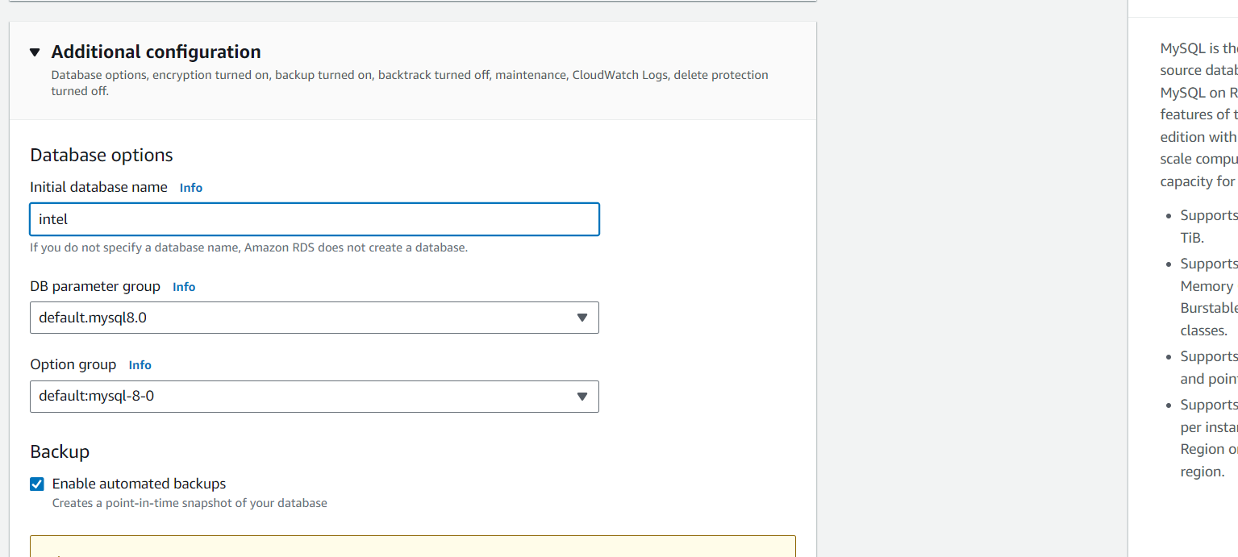

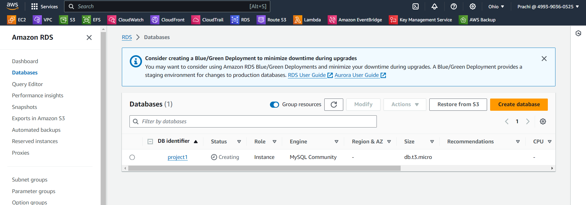

For autoscaling need to create AMI of instance for launch template

Creating AMI

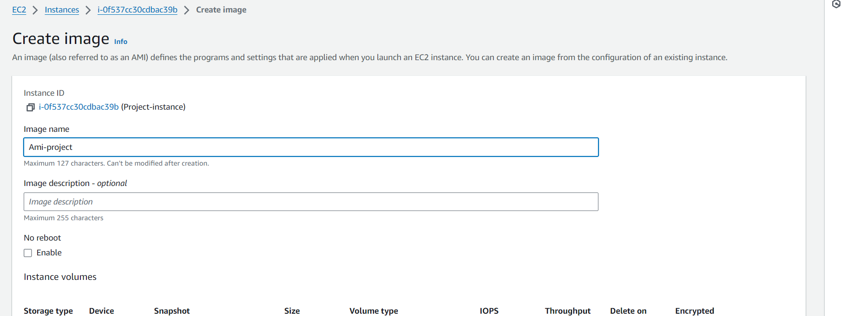

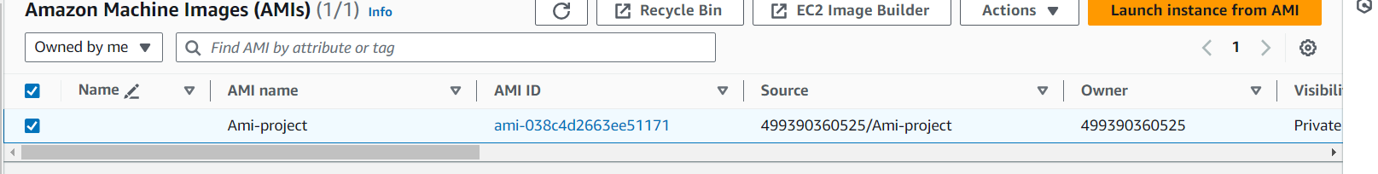

Creating autoscaling group and launch template

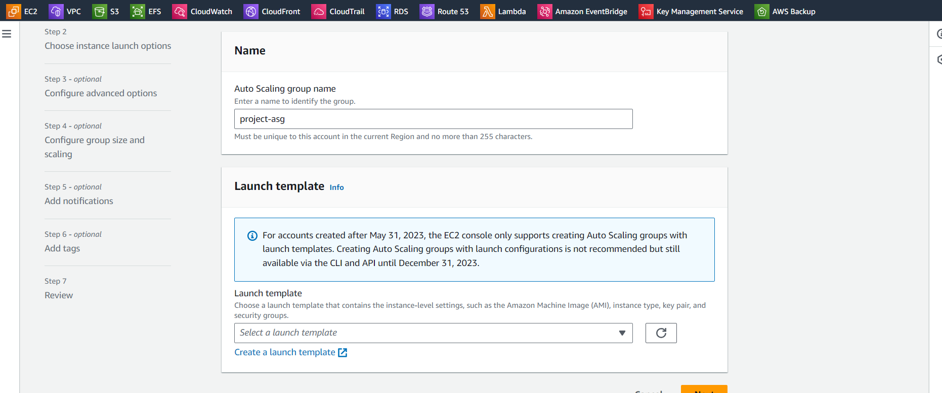

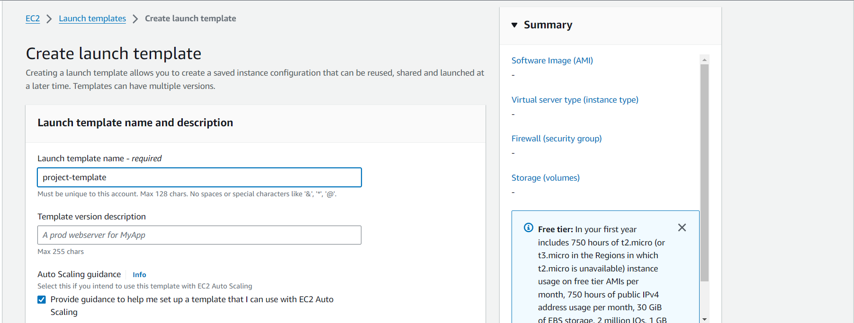

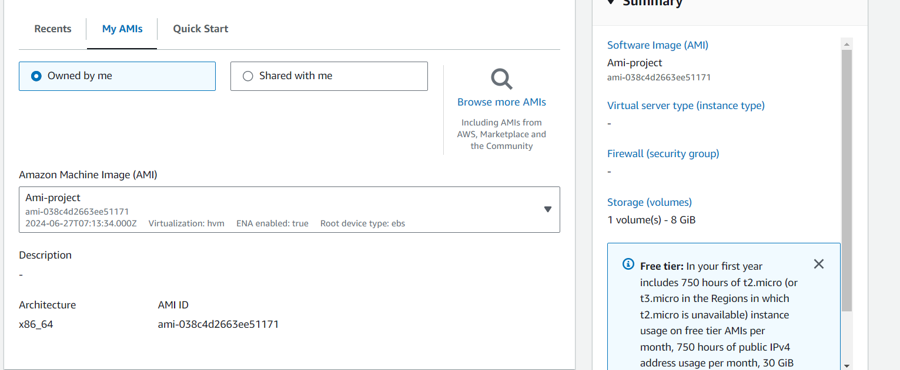

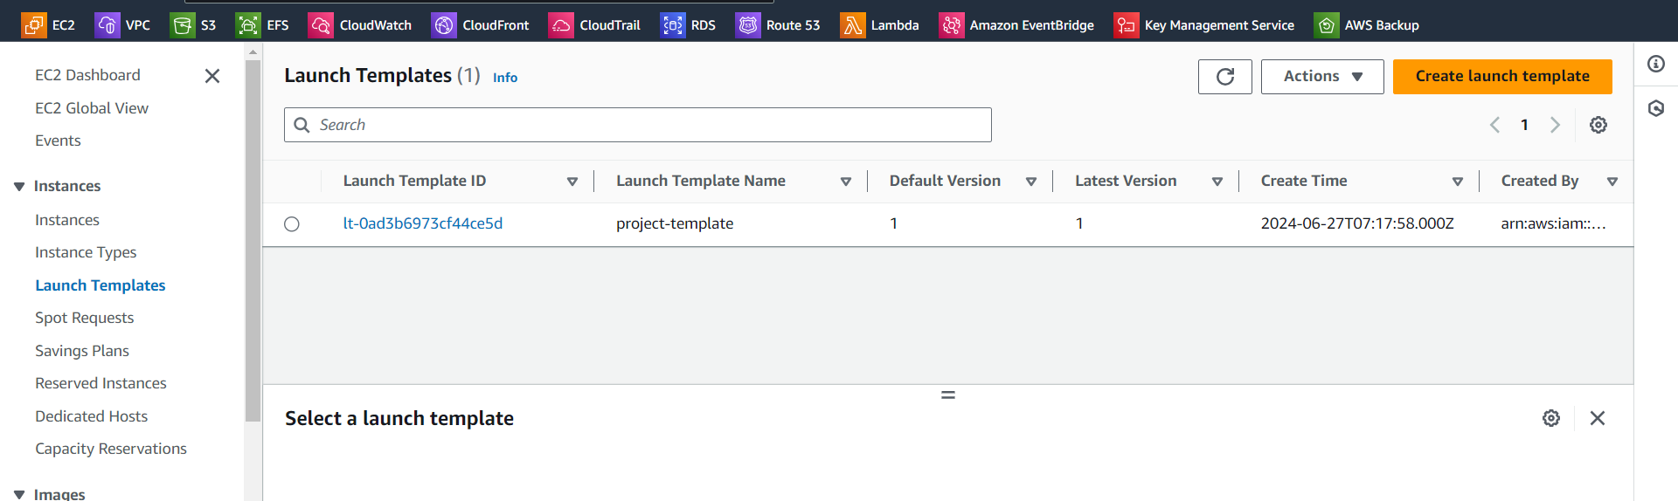

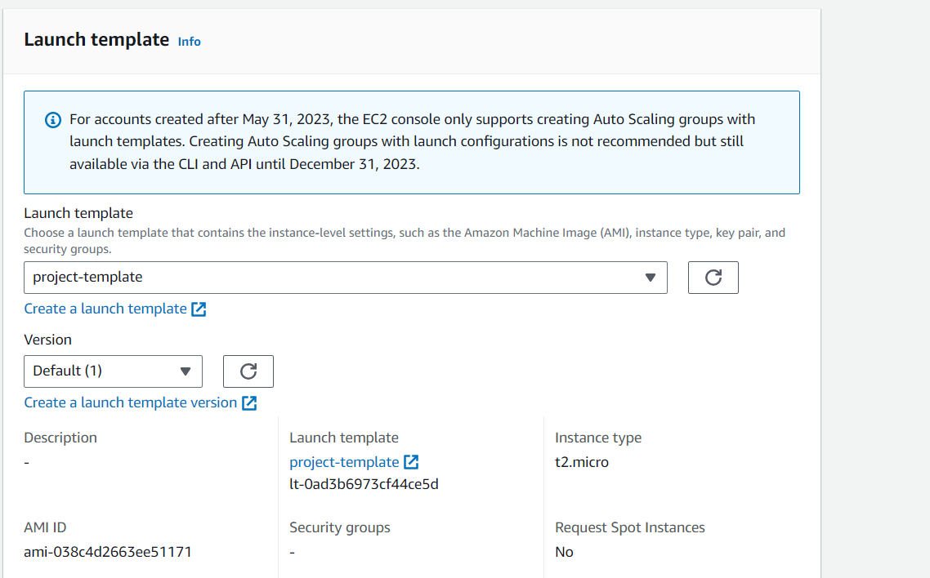

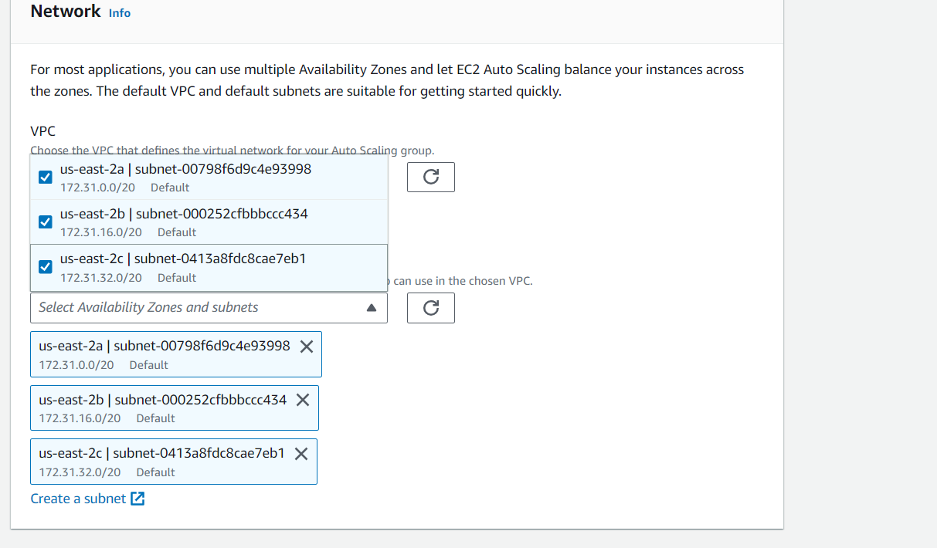

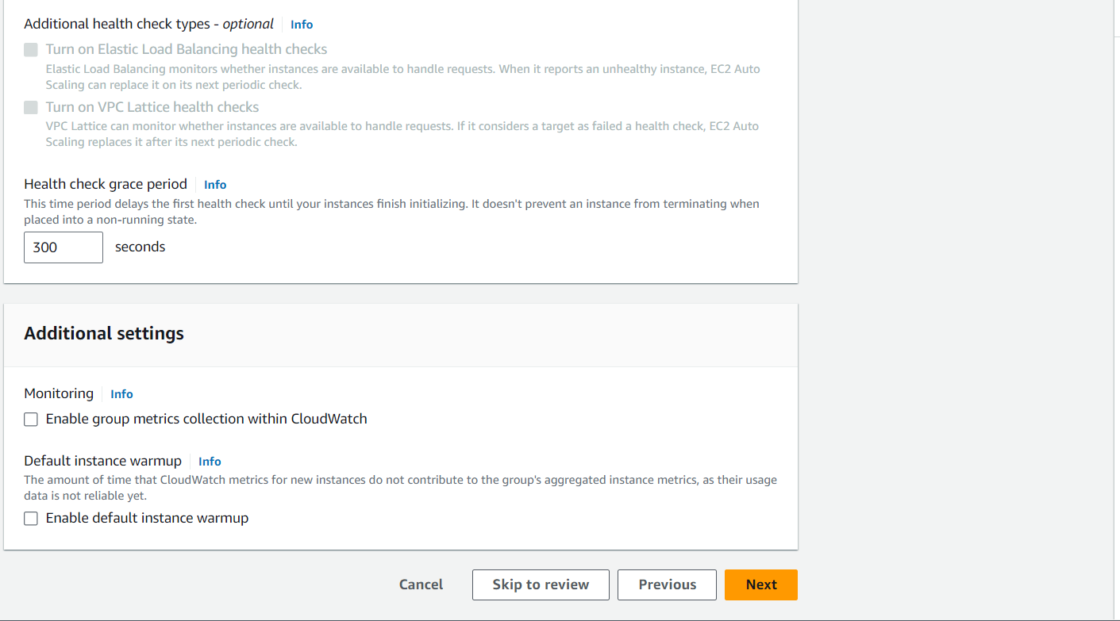

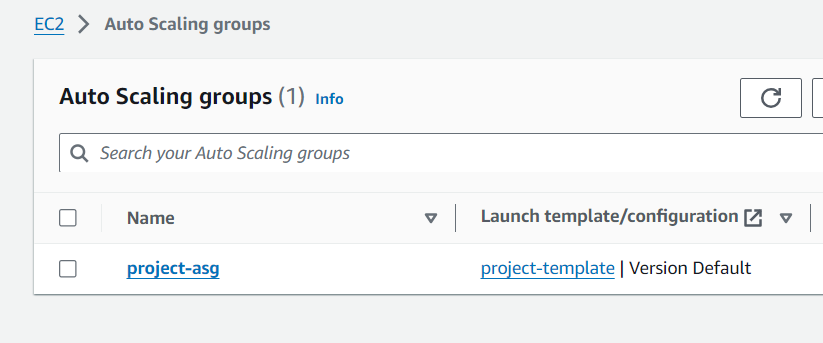

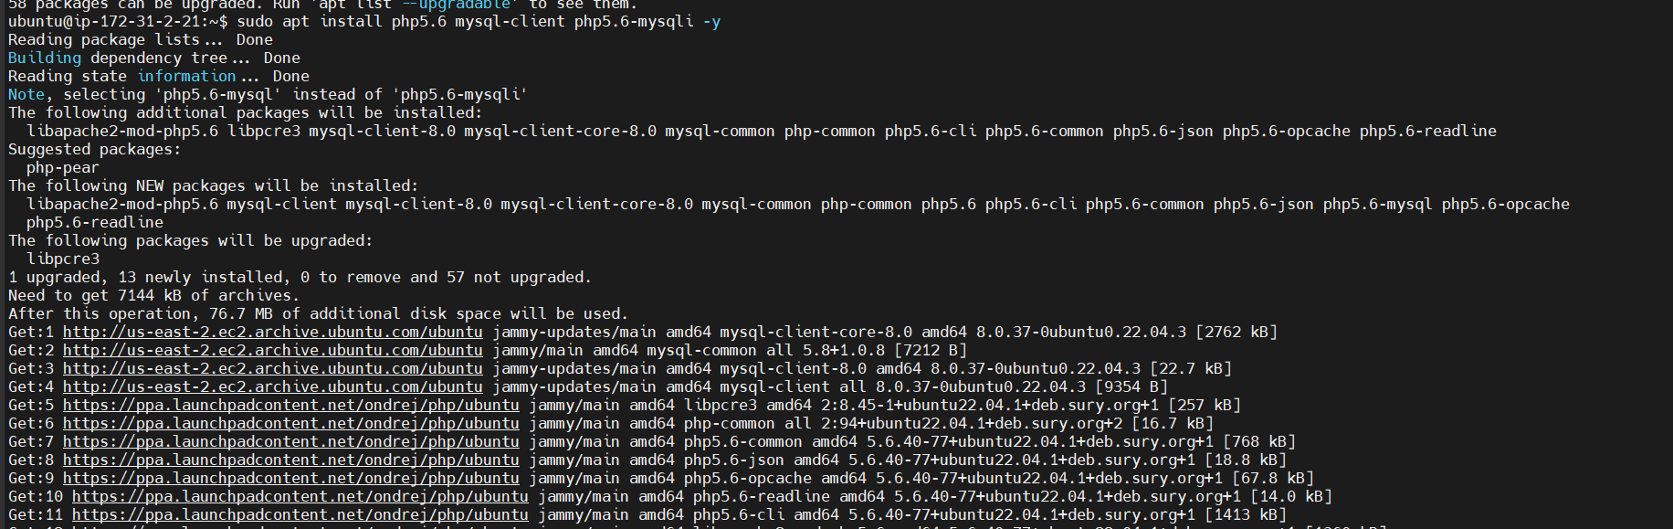

Copied endpoint of database

